Design of fractional order PID-type dynamic matrix control for fractional industrial processes

Dawei Wangª，Ridong Zhang^{a,b,*}，Furong Gao^{b}

- Information and Control Institute, Hangzhou Dianzi University, Hangzhou 310018, P R China
- Department of Chemical and Biomolecular Engineering, The Hong Kong University of Science and Technology, Clear Water Bay, Kowloon, Hong Kong

Abstract:
Most dynamic systems in practice are of fractional order and often the models using fractional order differential equations can describe their intrinsic properties with more accuration compared with conventional differential equations. In this paper, a fractional order PID-type dynamic matrix controller (FO-PIDDMC) is designed based on a fractional order model formulation of the industrial processes. The Oustaloup approximation method is first employed to derive the approximated model of the fractional order processes, which paves the way for the application of integer order dynamic matrix control method to the fractional order systems. Meanwhile, a set of PID-type operators are introduced in the cost function of the proposed dynamic matrix control for optimization. The resulting controller bears both the merits of the dynamic matrix control and the PID and thus improved control performance is obtained. Finally, an example of an industrial heating furnace is given to verify the proposed method in comparison with traditional integer order model based dynamic matrix control, and results show that the proposed fractional order controller yields improved control performance.
Keywords: fractional order calculus, fractional order system, dynamic matrix control, PID control, Oustaloup approximation

- Introduction
For industrial processes, the PID control and model predictive control (MPC) are the most widely used control technologies and lots of progress has been achieved. Dynamic matrix control (DMC) is a typical MPC algorithm that was first proposed by Culter in 1980 [1]. It extends the single-step prediction of traditional self-tuning technology to the multi-step prediction and carries out the receding horizon optimization based on the feedback information, such that the sensitivity of the algorithm to the variation of model parameters is effectively restrained, and the effects of the uncertainty factors such as environmental interference and modeling error are reduced [2-3]. DMC is effective in the control applications of industrial processes with strong coupling, nonlinearity, large time delay, etc [4-6]. However, DMC is usually designed on the basis of the asymptotically stable linear approximated model, which may require larger online computation and the sampling period should not be too small, leading to the fact that the disturbance cannot be restrained quickly. Therefore, it is meaningful to study the improvement of DMC algorithm for the control systems under various uncertainties [7].
On the other hand, the traditional PID control is a feedback control that is composed of three linear combinations such as the proportional, integral and differential of the feedback of system error. It is still widely used in the actual industrial process because of its simple control structure, easy operation, strong robustness and so on. However, with regard to the situation that the parameters of the process model are of nonlinearity, time varying uncertainty, and large inertia or time delay under the uncertain disturbance, it is difficult to apply conventional PID control to achieve the desired control effect [8-9]. In this regard, some methods were put forward to improve the control performance, for example, the cascade control of superheated steam temperature, such as DMC-PID which is also called predictive PID controller [10]. In this strategy, the weighted term of the steady-state error was introduced into the cost function of generalized predictive control (GPC), and the control law of GPC was established again based on the PID structure. The algorithm was decomposed according to the PID form, and a PID controller with prediction function was finally obtained. The advantages of PID and DMC control were further reported in [11], where the cost function of DMC was established again in the form of PID, and a new predictive control method was obtained.
The application of PID control and DMC in practice is based on process modeling, and the control performance of the system will be greatly influenced by the modeling accuracy. Modeling is an important component of the dynamic system control theory [12]. Describing the dynamic characteristics of the system and studying the subsequent control of the system from a mathematical point of view is the basis research of the control system design. The integer order model based control theory is now mature and widely used. In practice, most of the dynamic systems are of fractional order [13] and the integer order differential equation model will only describe part of the dynamic characteristics of such systems. Thus research on extending the control method of the integer order model based control theory to the fractional order system is a meaningful job. The polynomial model of fractional order systems and the state space models were given in [14]. In [15-17], different models described by the fractional order differential equation, the state space model, the transfer function model, the fractional difference equation and the fractional order discretization are discussed and studied, and detailed description about mutual transformation among the models are also given.
The number of arbitrary orders and the distinctive memory feature of fractional order calculus can reflect the inherent characteristics of these systems more precisely. Fractional order controller is a controller in which the fractional calculus operator is introduced and utilized. Among the fractional order model based control, the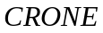controller proposed by Oustaloup et al. is the most representative and its development has experienced three generations [18-20]. Another typical fractional order controller is the 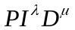controller proposed by Podlubny[21]. Compared with traditional PID controllers, fractional order controllers are more flexible and effective and thus more and more attention is attracted. In [22], the simulation of fractional order controller was studied, whose results show that the fractional order controller has strong robustness. Since theoretical research shows that the control performance of the fractional order controller is better than that of integer order controller [23], study on the control of the fractional order systems has become a hot topic recently.
Existing research focusing on the fractional order model based controller design has been reported in [24]. Furthermore, advanced control based on fractional order models is also emerging rapidly. In [25-26], Rhouma et al proposed a MPC of fractional order control system with satisfactory performance, in which the numerical approximation model and Oustaloup approximation model were used to predict the future dynamic output of the system. The fractional order implementation method and the application of a novel predictive controller RTD-A was studied in [27]. In [28], the design and implementation of MPC based on the fractional Kalman filter was proposed, and the estimated state was used for the optimal state feedback control of MPC. In [29], the fractional order model reference adaptive control scheme was studied and the control law improves the dynamic performance of the closed-loop system. Romero, et al. proposed a new GPC algorithm for fractional order systems where the fractional order operator was introduced into the cost function [30-31]. In [32], an adaptive GPC algorithm was designed for the fractional order dynamic model of solid oxide fuel cells.
As is shown above, there are quite limited research results on the application of MPC in fractional order systems. Also, the control performance still needs to be further improved since fractional order model based control is not mature. In this paper, a PID-type dynamic matrix control (PID-DMC) approach is designed based on fractional order linear system theory. Firstly, Oustaloup approximation method is utilized to derive the approximated model of the fractional order systems. Secondly, a PID-type operator is introduced into the cost function that will make the adjustment of subsequent control parameters more flexible. Lastly, the fractional order DMC control law is derived based on fractional calculus and the idea of integer order DMC method.
This paper is organized as follows. In section 2, the theory of fractional calculus is described, and the specific forms of the definitions of three kinds of fractional calculus are given. In section 3, the design procedure of PID-type DMC for fractional order systems (FO-PIDDMC) is presented. We first deal with the fractional order model by using the Oustaloup approximation method to obtain the higher order integer order model. Then, the DMC of the integer order model is extended to the control of the fractional order system, where the PID operator is introduced into the cost function. As a result, the optimal control law is obtained. In section 4, the performance of the FO-PIDDMC is verified by simulation on a heating furnace. Results show that the proposed fractional order controller will improve the control performance in comparison with the traditional integer order model based DMC. Finally, conclusion is summarized in section 5.
- The theory of fractional calculus and fractional model
Fractional calculus, which is also known as the generalized calculus, is an extension of the traditional calculus, that is to say, the derivative of the function in the differential equation can be chosen as a fraction instead of an integer. Actually, it is a non-integer order calculus or any order of calculus, and the order can be real or even plural. There is no uniform definition of fractional calculus so far, which is one of the reasons why it has not been widely applied. With the development of the fractional calculus theory, many definitions and research results of fractional calculus have been proposed. The most three common definitions are Grünwald-Letnikov(GL) fractional calculus definition, Riemann-Liouville(RL) fractional calculus definition and Caputo fractional calculus definition [33]. The mathematicians give several different definitions of fractional calculus from different points of view respectively, and the rationality of the definition has been verified in practice. Next, the three kinds of specific forms of fractional calculus definition will be given below.
2.1 Grünwald-Letnikov(GL) fractional calculus definition
The numerical algorithm of fractional derivative can be directly derived by using Grünwald-Letnikov(GL) definition of fractional calculus, which is the most widely used in the fractional order control, and the specific form is described as follows:
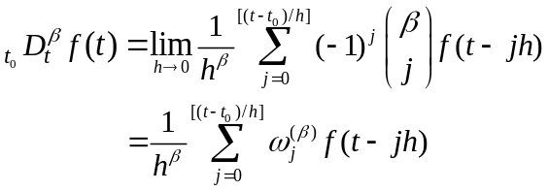 (1)
where, 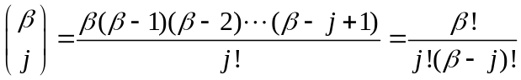,is initial state time, is the sampling step length,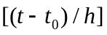is the integer part of the number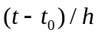,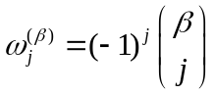is the polynomial coefficients that can be obtained directly from the following recursion formula:
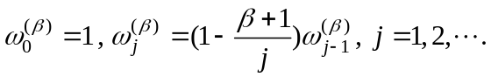 (2)
Taking into account the short-term memory of the fractional order calculus algorithm and its application in the practical process, the sampling time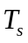is used to replace the computation step. For simplicity, this paper considers the zero initial condition, and by denoting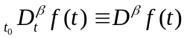, GL definition can be further converted into the following form:
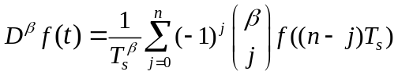 (3)
where,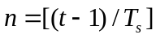.
2.2 Riemann-Liouville(RL) fractional calculus definition
Riemann-Liouville definition is the most commonly used fractional calculus definition recently, and its formulation is as follows:
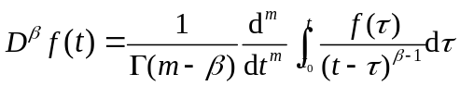 (4)
where, 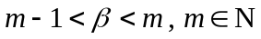,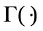 is the famous Euler gamma function, 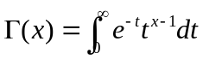.
The Laplace transform of RL is:
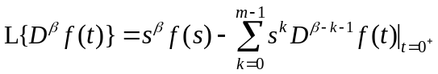 (5)
For convenience, the transformation results for the initial condition are given:
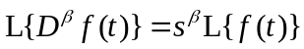 (6)
2.3 Caputo fractional calculus definition
Caputo fractional calculus is defined as:
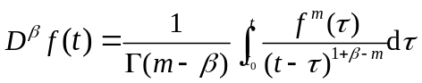 (7)
The Laplace transform of Caputo definition is:
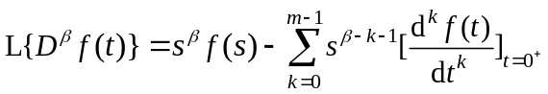 (8)
2.4 Representation of fractional order systems
For simpilicity, the typical single input single output (SISO) linear systems is considered here, and the differential equation form of the typical fractional order can be described as follows:
(9)
where, 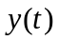,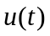are the output and input of the controlled system respectively, 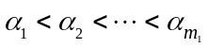，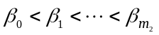 are the fractional orders, 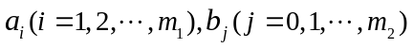 are arbitrary real numbers.
Combining with the RL definition and its Laplace transformation in Eq.(6), the fractional order system with zero initial condition can be written as the following transfer function model:
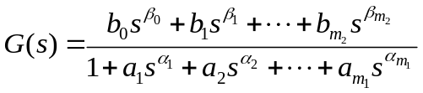 (10)
In this paper, the Laplace transform of RL definition is used to describe the fractional order system.
- Fractional order PID dynamic matrix control
In this section, FO-PIDDMC algorithm is introduced to the control of fractional order systems.
3.1 Processing of fractional order model
It is difficult to directly derive the algorithm for fractional order systems since most of the controller designs are just applicable for integer order systems. Considering this fact, the numerical solution of fractional order differential equations is solved by using the Oustaloup approximation method [34].
The Oustaloup approximation method is expressed as follows:
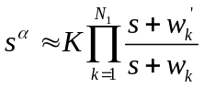 (11)
where, 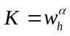, 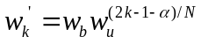, 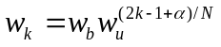, 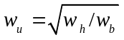and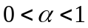,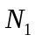 is the selected approximation order, 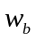,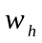are the upper and lower bounds of the fitting frequencies, respectively.
By using the Oustaloup approximation method, Eq.(11) is substituted into the fractional order systems in Eq.(10), which is described in the form of fractional order transfer function, and the higher order approximation of an integer order system model can be obtained. The higher order model with the zero order holder are discretized with the sampling time and the difference equation model of the process is further obtained as follows:
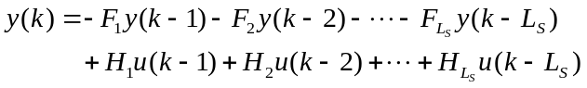 (12)
where, 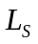 the length of the discrete model, 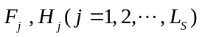are coefficients obtained from the discrete approximation, respectively.
3.2 Design of the FO-PIDDMC controller
The model vector 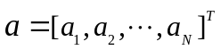of the higher order system is obtained by step response test，in whichis the modeling horizon, 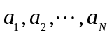 are the step response parameters obtained by sampling in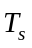. Moreover, the dynamic matrix form of the model is as follows:
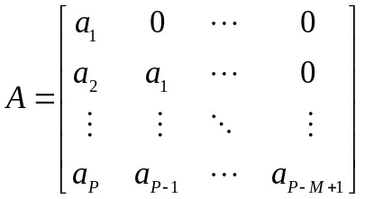 (13)
where,  is the dynamic matrix of the controlled process whose dimension is 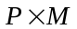, and 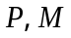are the predictive horizon and control horizon of the DMC, respectively, with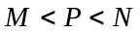.
The predicted output value of the model is obtained by addingcontrol increment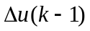at the time instant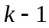:
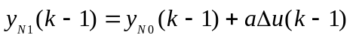 (14a)
where,
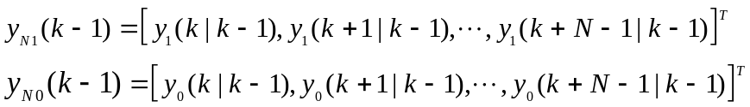 (14b)
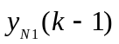 is the future predicted output by adding the control incrementat the time instant , 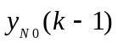is the initial predicted output at the time instant ,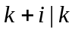denotes the prediction for time instant 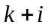made at time instant .
It needs to modify the future output prediction because of the output prediction error caused by the uncertainty of the model, and the form of the modified method is selected as follows:
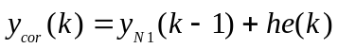 (15a)
where,
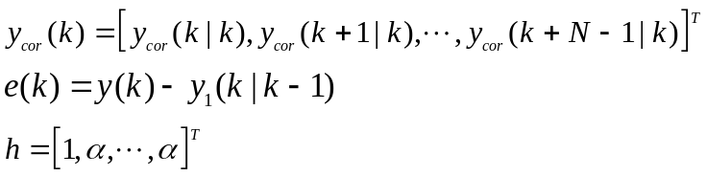 (15b)
Here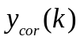is the correction value for future output prediction at time instant, 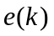 is the error between the actual process output and the model output prediction at time instant,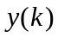 is the actual process output value measured at time instant, is the error correction vector, and is the error correction vector coefficient.
It is required to shift the elements of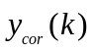to form the initial output prediction at time instant, and the shifting process is as follows:
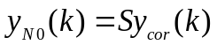 (16a)
where，is the state shifting matrix whose dimension is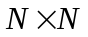,
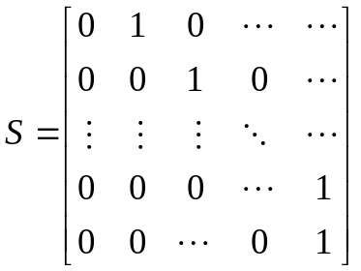 (16b)
Due to the existence of model truncation,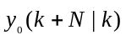, which is the last element of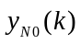, will be replaced by 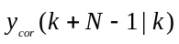.
After obtaining the initial output prediction at time instant, continuous control increment are added to get the output prediction of the future model as follows:
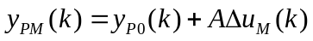 (17a)
where,
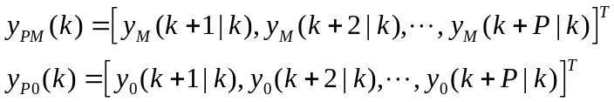 (17b)
Here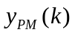is the future output prediction at time instantunder the action of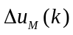, and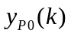is the initial output prediction at time instant .
The reference trajectory and the cost function of the fractional order DMC is selected as follows:
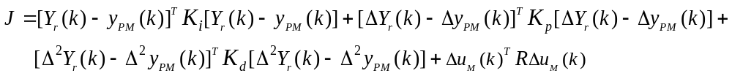 (18a)
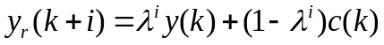 (18b)
where
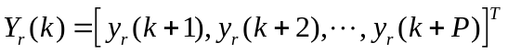
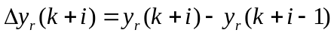 (18c)
(18d)
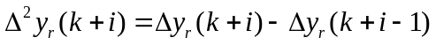 (18e)
(18f)
Here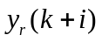is the reference trajectory of the desired output,is the measured output of the process at time instant,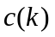is the desired output at time instant, is the smoothing factor of the reference trajectory, 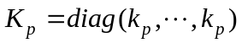，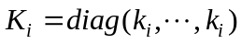，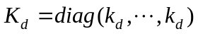 are the proportion coefficient matrix, the integral coefficient matrix and the differential coefficient matrix respectively. 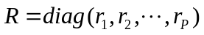 is the weighting coefficient matrix on the control input.
Define
(19a)
(19b)
(19c)
By substituting Eq.(19a)-Eq.(19C) into Eq.(18a), the cost function can be transformed into the following form
(20)
Combining Eq. (18c), Eq. (18d), Eq. (19b) with Eq. (19c), we can obtain
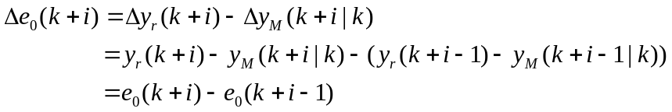 (21)
In the same way
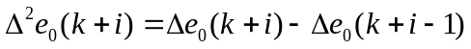 (22)
For convenience, we specifically define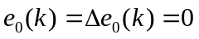
By introducing a matrix
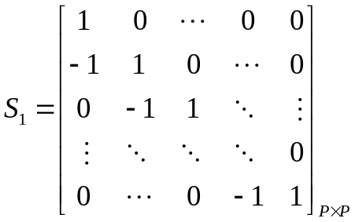
we can obtain
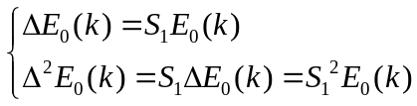 (23)
Substituting Eq.(23) into Eq.(20), the cost function is further transformed into the following form
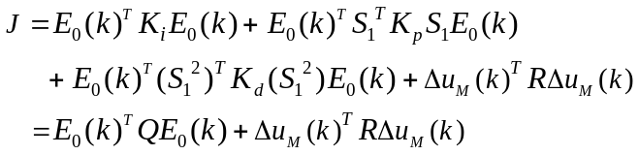 (24)
where 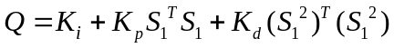
By using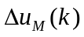as the control variable, the minimum value of the cost function Eq. (24) is solved with 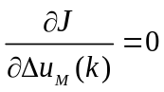, and the optimal control law is obtained as follows:
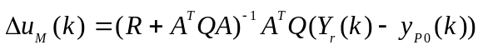 (25)
Define 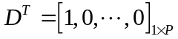, and the actual control increment of the controlled process can be obtained as:
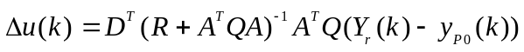 (26)
- Case study
In this section, we present the simulation results of the proposed FO-PIDDMC on the temperature model of a heating furnace.
4.1 Introduction of process flow of heating furnace
Fig.1 shows the process flow of the temperature control system of the heating furnace (SXF-4-10). The temperature of the heating furnace(SXF-4-10) is detected by K type thermocouple and converted to a voltage signal. The voltage signal will be amplified by the signal amplifier (SG-3011 CR) and sent to the signal acquisition card (CR PCI-1802LU). Then the voltage signal is converted to the corresponding temperature value in the computer. The digital signal 0x01 from the computer to the signal output card (PIO-D24U) will be transformed into a voltage of +5V for heating, which is done by sending it from the cable (DN-3710 CR) to the solid state relay (SSR-380D40). When the digital signal from the computer is 0x00, the corresponding voltage is 0V and the furnace is disconnected.
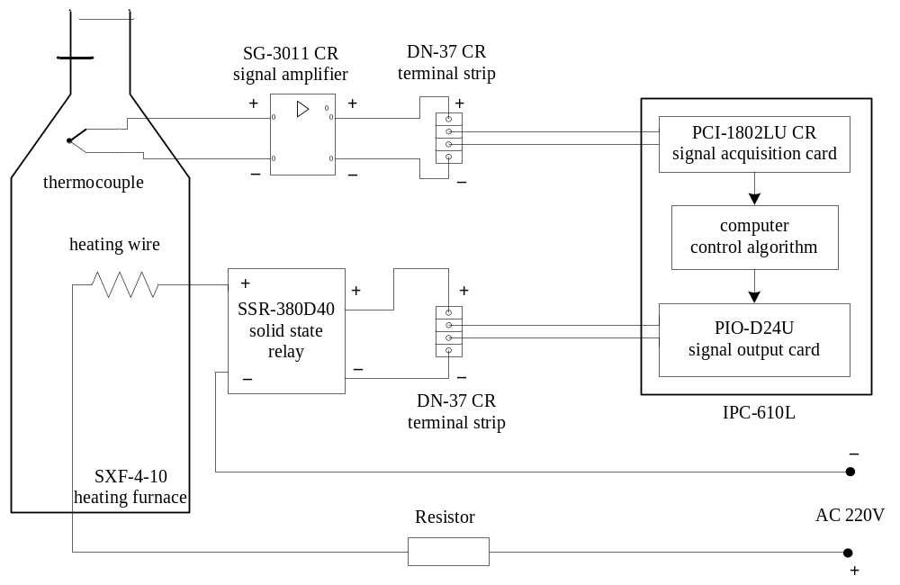
Fig.1. The temperature control system of high temperature resistance furnace (SXF-4-10).
4.2 The process model
By collecting the real-time temperature data of the heating furnace, the fractional order model and the first order plus dead time model of the heating furnace can be obtained. Here the first order plus dead time model is obtained using the standard two-point method described in [35] and the fractional order model is further obtained based on the first order plus dead time model with trial and error. The two obtained models are as follows
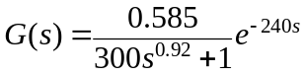 (27)
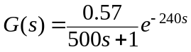 (28)
The fractional order model Eq.(27) is further treated into the higher order model by Oustaloup method:
(29)
where the approximation order of the differential operator is selected as N=4, and the upper and lower fitting frequencies of the Oustaloup approximation are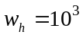and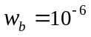respectively.
The output values of the three models are compared with the temperature process data and results are shown in Fig. 2 and Table 1.
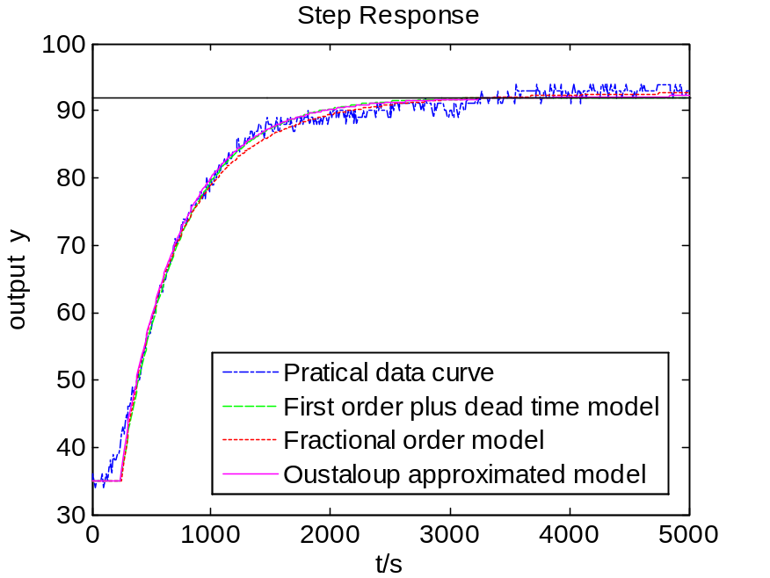
Fig. 2. The output contrast curve of model step response
Table 1. Comparison results of the output values of the three models
Model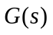 | Standard Deviation
Fractional model | 1.4856
First order plus delay time model | 1.7592
Oustaloup approximated model | 1.5000
From Fig.2 and Table 1, we can find that the fractional order model can model the process more accurately, and the modeling error of the first order plus dead time model using two points method is the largest.
In this paper, the sampling time is selected as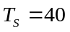. The zero-order hold is added to the model in Eq.(28) so that it can be discretized, and the following form of the discrete model is obtained:
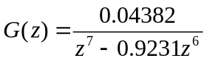 (30)
Meanwhile, the discrete model of Eq.(29) is obtained as follows:
(31)
4.3 Simulation results and analysis
In order to verify the effectiveness of the proposed method, we use MATLAB simulation to compare the FO-PIDDMC method with the integer order DMC method. The controller of the FO-PIDDMC is designed based on the nominal Oustaloup approximated model shown in Eq.(31), while the first order plus dead time model Eq.(30) is adopted as the model to design the controller of the integer order DMC. Finally, the two obtained control laws are both implemented on the Oustaloup approximated model obtained through the real fractional order process. The set-point is selected as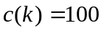, the amplitude of the output disturbance added at time instant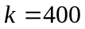is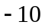, and the control effects of model/plant match and mismatch are both considered respectively.
4.3.1 Model/plant match case
Here the parameters of the two controllers are both set as. Moreover, additional parameters for the proposed FO-PIDDMC are selected as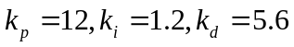.Fig.3 shows the responses of the controlled system under the model match case. We can easily find that both the FO-PIDDMC and the integer order DMC can obtain the stable control, and there are no oscillations and overshoots in the responses of the two controllers. Compared with the integer order DMC controller, the FO-PIDDMC has better tracking performance, faster rising speed and stronger disturbance rejection ability.
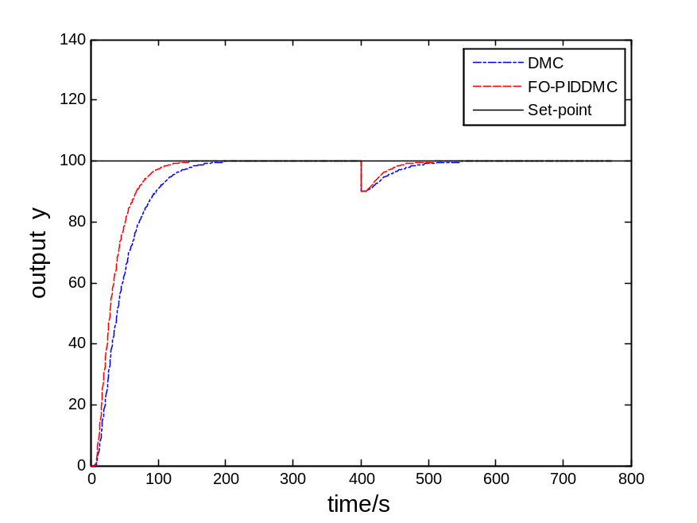
Fig. 3a. Closed-loop output responses under no model/plant mismatch
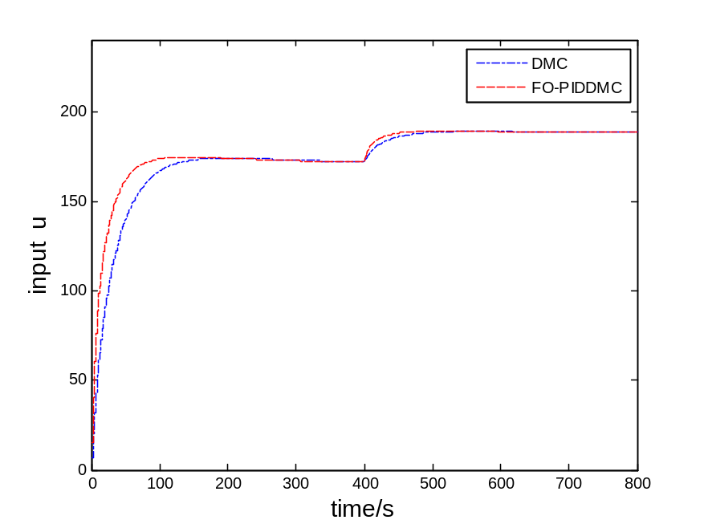
Fig. 3b. Closed-loop input signals under no model/plant mismatch
4.3.2 Model/plant mismatched case
Since there are often uncertain factors in practice causing a certain model/plant mismatch, this section will mimic such situation through Monte Carlo method. Here three groups of random process parameters resulted from the ±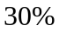 uncertainty of the process parameters shown in Eq.(27) are generated to stand for the actual process as follows
case 1： 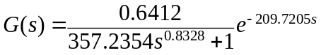 (32)
case 2： 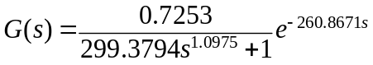 (33)
case 3： 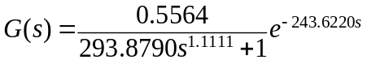 (34)
Now the controller of the FO-PIDDMC is still designed based on the nominal Oustaloup approximated model shown in (31), and the first order plus dead time model Eq.(30) is still adopted as the model to design the controller of the integer order DMC. However, the two obtained control laws are both implemented on the Oustaloup approximated models obtained through the real fractional order processes shown in Eqs.(32)-(34).
The control parameters of the controllers are the same as those in the model/plant match case. The results are shown in Figs.4-6. From the responses, it can be found that the control performance of the two models is still stable. However, we can easily find that the FO-PIDDMC has improved control performance compared with that of the integer order DMC. It can be seen from Fig.4 that the response speed of the integer order controller is relatively slower. The situations in Fig.5 and Fig.6 are like those in Fig.4, where the FO-PIDDMC has faster rising speed and stronger disturbance rejection ability. In a word, the FO-PIDDMC has improved dynamic and robust performance.
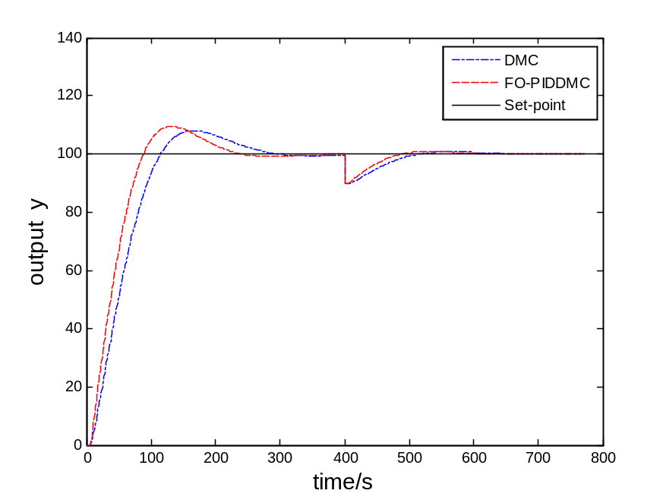
Fig. 4a. Closed-loop output responses for case1 under model/plant mismatch
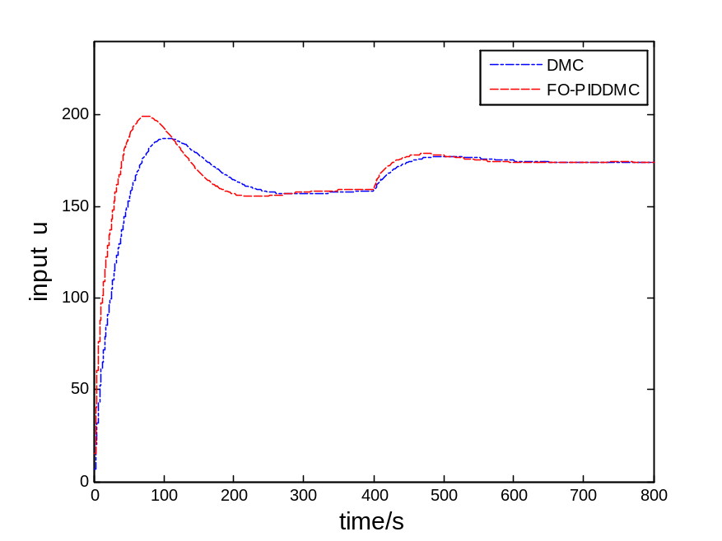
Fig. 4b. Closed-loop input signals for case1 under model/plant mismatch

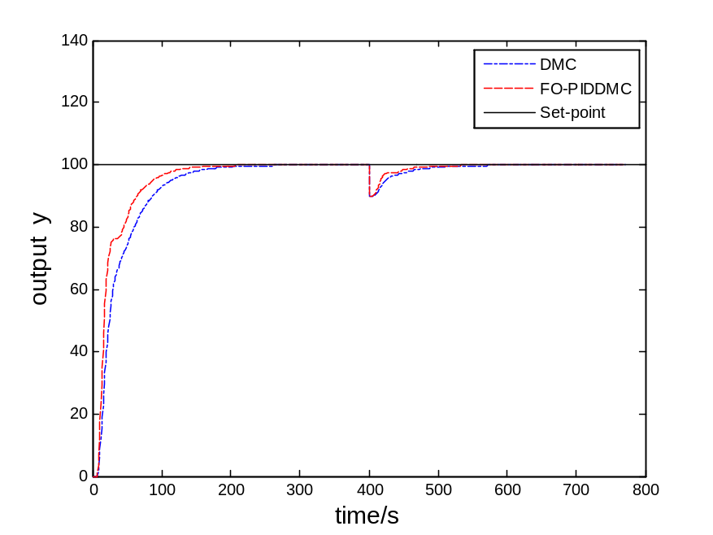
Fig. 5a. Closed-loop output responses for case2 under model/plant mismatch
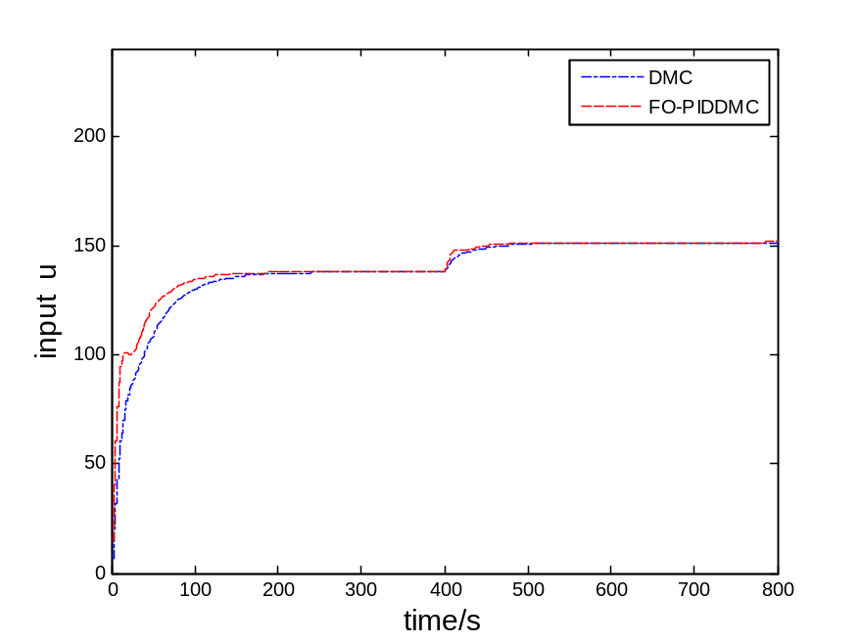
Fig. 5b. Closed-loop input signals for case2 under model/plant mismatch

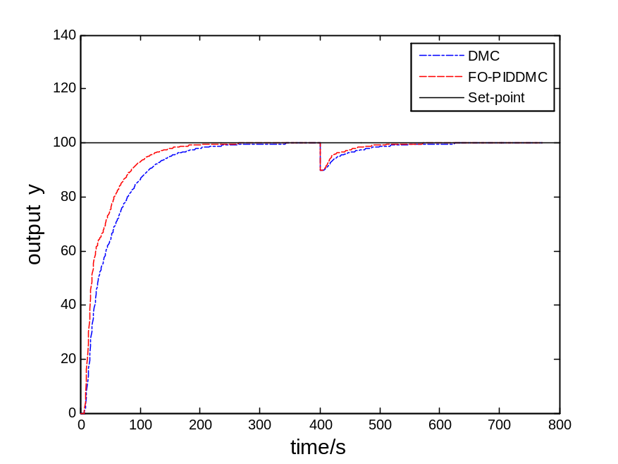
Fig. 6a. Closed-loop output responses for case3 under model/plant mismatch

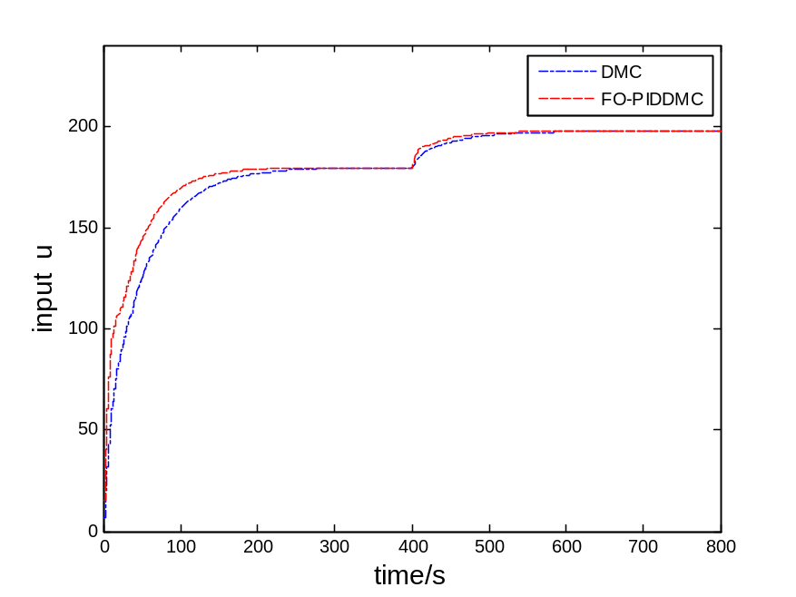
Fig. 6b. Closed-loop input signals for case3 under model/plant mismatch
- Conclusion
In this paper, the PID-type dynamic matrix control of fractional order systems is presented for fractional order linear systems. The traditional PID control is combined with the dynamic matrix control in the proposed approach, which further extends the integer order dynamic matrix control application in the fractional order systems. The designed fractional order controller showed improved dynamic and robust performance, which is due to the flexible adjustment of control parameters. Finally, the effectiveness of the proposed method is verified by a simulation example of a heating furnace.
References
[1] Culter, C. R., Ramaker, B. L. Dynamic matrix control-A computer control algorithm, San Francisco: Joint Automatic Control Conference, 1980.
[2] Akesson, B. M., Toivonen, H.T. A neural network model predictive controller, Journal of Process Control, 2006, 16 (9): 937-946.
[3] Lu, C.H., Tsai, C. C. Generalized predictive control using recurrent fuzzy neural networks for industrial processes, Journal of Process Control, 2007, 17 (1): 83-92.
[4] Liu, Y. F., Wu, G., Wang, Y., Xue, M. S., Sun, D. M. Stair-like modular multivariable DMC controller and its application in atmospheric petrochemical furnace, IEEE Transactions on Intelligent Control and Automation, 2002, 3:2461-2464.
[5] Zhou, F. E., Bi, X. H. Dynamic matrix predictive control algorithm's application research in process control, Journal of Changsha Aeronautical Vocational and Technical College, 2005,4 (4) :43-45.
[6] Yu, S. M., Du, W. Dynamic matrix control algorithm with stochastic time-varying parameters and its application in temperature plant of hot water networks, Chinese Journal of Scientific Instrument, 2003, 24 (3): 300-303.
[7] Ma, P., Zhou, Y. H. Simulation study of model predictive control on superheated-steam temperature control at power plant, Electric Power Science and Engineering, 2010, 26 (10): 43-46.
[8] Liu, K., Xu, H. H. The simulation of composite fuzzy control system to superheated steam temperature of thermal power plant, Computer Engineering and Applications, 2004, (18):212-214.
[9] Qiu, T., Ding, Y. J., Wu, Z. S., Zhang, Y., Kong, L., Zhang, X. A new fuzzy-weighted control used multiple PID controller based on prediction model , Proceedings of the Chinese Society for Electrical Engineering, 2006, 26(24):121-124.
[10] Kwok, K. E., Ping, M. C., Li, P. A model-based augmented PID algorithm, Journal of Process Control, 2000, 10 (1): 9-18.
[11] Yao, S. J., Guo, W. Improved PID dynamic matrix control algorithm based on time domain, Chinese Journal of Scientific Instrument, 2007, 28(12):2174-2178.
[12] Zhu, C. X., Zou, Y. Summary of research on fractional-order control, Control and Decision, 2009, 24(2):161-169.
[13] Mehmet, E., Senior, M. Fractional order systems in industrial automation—a survey, IEEE Transactions on Industrial Informatics, 2011, 7(4): 582-590.
[14]Busłowicz, M. Stability of State-Space Models of Linear Continuous-Time Fractional Order Systems, Acta Mechanica et Automatica, 2011, 5:15-22.
[15] Wang, Z. B. Fractional order linear system and its applications, PhD thesis, Shanghai Jiaotong University, 2004.
[16] Qin, C. M., Qi, N. M., Zhu, K. State space modeling and stability theory of variable fractional order system, Control and Decision, 2011, 26(11):1757-1760.
[17] Wang, Z. B., Cao, G. Y. Two system modeling methods using fractional calculus, Journal of System Simulation, 2004, 16(4):810-812.
[18] Oustaloup, A., Bansard, M. First generation CRONE control, Proceedings of International Conference on Systems, Man and Cybernetics. IEEE, 1993,130-135.
[19] Oustaloup, A., Mathieu, B., Lanusse, P. Second generation CRONE control, Proceedings of International Conference on Systems, Man and Cybernetics. IEEE, 1993,136-142.
[20] Lanusse, P., Oustaloup, A., Mathieu, B. Third generation CRONE control, Proceedings of International Conference on Systems, Man and Cybernetics. IEEE, 1993,149-155.
[21] Podlubny, I. Fractional-order systems and 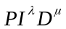-controllers, IEEE Transactions on Automatic Control, 1999, 44(1): 208-214.
[22]Zeng, Q. S., Cao, C. Y., Zhu, X. J. The effect of the fractional-order-order controller's order's variation on the fractional-order-order control systems, Proceeding of the First International Conference on Machine Learning and Cybernetics, Beijing, 2002, 367-372
[23] Xue, D. Y., Zhao, C. N. Fractional order PID controller design for fractional order system, Control theory and applications, 2007,24(5): 771-776.
[24] Özbay H., Bonnet C., Fioravanti A. R. PID controller design for fractional-order systems with time delays, Systems & Control Letters, 2012, 61(1):18-23.
[25] Rhouma, A., Bouzouita, B., Bouani, F. Model predictive control of fractional systems using numerical approximation. World Symposium on Computer Applications & Research, IEEE, 2014, 1-6.
[26] Rhouma, A., Bouzouita, B., Bouani, F. Practical application of model predictive control to fractional thermal system. Second International Conference on Informatics and Applications, IEEE, 2013, 222-227.
[27] Li, D. Z., Cao, J., Guan, S. T. et al. Research and implementation of a fractional predictive controller, Control Theory & Applications, 2010, 27(5): 658-662.
[28] Ji, Z. H., Li, D. Z. Design and implementation of a model predictive controller based on a fractional Kalman filter, Journal of Beijing University of Chemical Technology(Natural Science Edition). 2014, (2): 109-113.
[29] Vmager, B. M., Petra’s, L., Podlubny, L. et a1. Using fractional-order order adjustment rules and fractional-order order reference models in model-reference adaptive control, Nonlinear Dynamics, 2002, 29: 269-279.
[30] Romero, M., et al. Fractional-order generalized predictive control: Application for low-speed control of gasoline-propelled cars, Mathematical Problems in Engineering, 2013, (2):289-307.
[31] Romero, M., de Madrid, A. P., Mañoso, C., Milanes, V., Vinagre, B. M. Fractional order generalized predictive control: Formulation and some properties .11th International Conference on Control, Automation, Robotics and Vision, Sigapore, 2010, 1495-1500.
[32] Deng, Z. H., Cao, H. L., Li, X., Jiang, J. H., Yang, J., Qin, Y. Generalized predictive control for fractional order dynamic model of solid oxide fuel cell output power, Journal of Power Sources, 2010, 195(24), 8097-8103.
[33] Monje, C. A., Chen, Y. Q., Vinagre, B. M. et al. Fractional order systems and controls fundamentals and applications, Advances in Industrial Control, London: Springer Verlag London Limited, 2010.
[34] Xue, D. Y. Computer aided control systems design—using MATLAB language, 3rd ed.; Beijing, 2012, 471-472.
[35] Zhang, R. D., Cao, Z. X., Lu, R. Q., Li, P., Gao, F. R. State-Space Predictive-P Control for Liquid Level in an Industrial Coke Fractionation Tower, IEEE Transactions on Automation Science and Engineering, 2015,12(4):1516-1524.

